**Rapid Prototyping Computer System Report**

Software Infrastructure

Wanjun Xu 徐宛筠

1 Function Requirements ------------------------------------------------------------1

2 Feature Comparison ----------------------------------------------------------------2

2.1 Database -------------------------------------------------------------------------2

2.2 Programming Language ------------------------------------------------------2

2.3 Server -----------------------------------------------------------------------------2

3 Various Ends --------------------------------------------------------------------------3

3.1 Android ----------------------------------------------------------------------------3

3.2 PC ----------------------------------------------------------------------------------5

3.3 Website ----------------------------------------------------------------------------7

4 Lesson Learned -----------------------------------------------------------------------9

**1 Function Requirements**

Challenge: The Children’s School at CMU challenged the Rapid Design and Prototyping for Computer systems class to:

● Help track the locations and activities of all members of the school

● Help make dismissal an easier and less stressful process

The whole class discussed together and had a vision scenario. According to the Human Computer Interaction Group, we have known the functions we need to implement and the other requirements we have to complete for connections with other group.

Functions Requirements:

1. Show the information to the parents and the teachers  
2. Provide user control, for example: log in/out  
3. Provide message service, send and receive message or notification between teachers and parents   
4. Show the result of data analysis, or the graph of data visualization

Other requirements:

1. Read and send data from database  
2. Provide API to Data Visualization Group to show the result

**2 Feature Comparison**

Our group member compared the mainstream database, programming language, server and decided the ones which suit the situation most.

2.1 Database

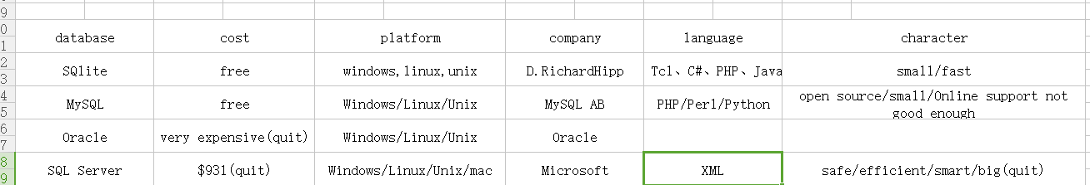

SQLite is very small and fast .So it is very good for a mobile phone. Besides ,SQLite can be applied to WEB and APP ,which others can’t. Finally we choose SQLite.

2.2 Programming Language

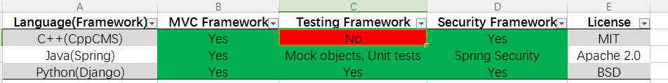

Each of us have different skills. So we divide the work into PC, APP and website. We use C# to make a executable program in PC ,use Java to make APP and use HTML, css, JavaScript to make the website.

2.3 Server

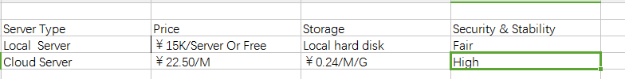

Cloud Server is maintained by Pro Team, thus has better Security. A PC owned by Child school can play the role of Local Server thus the cost would be free. We select Local server, since it could fulfill our demands, and is much cheaper.

**3 Various Ends**

3.1 Android

Different interface for parent and teacher

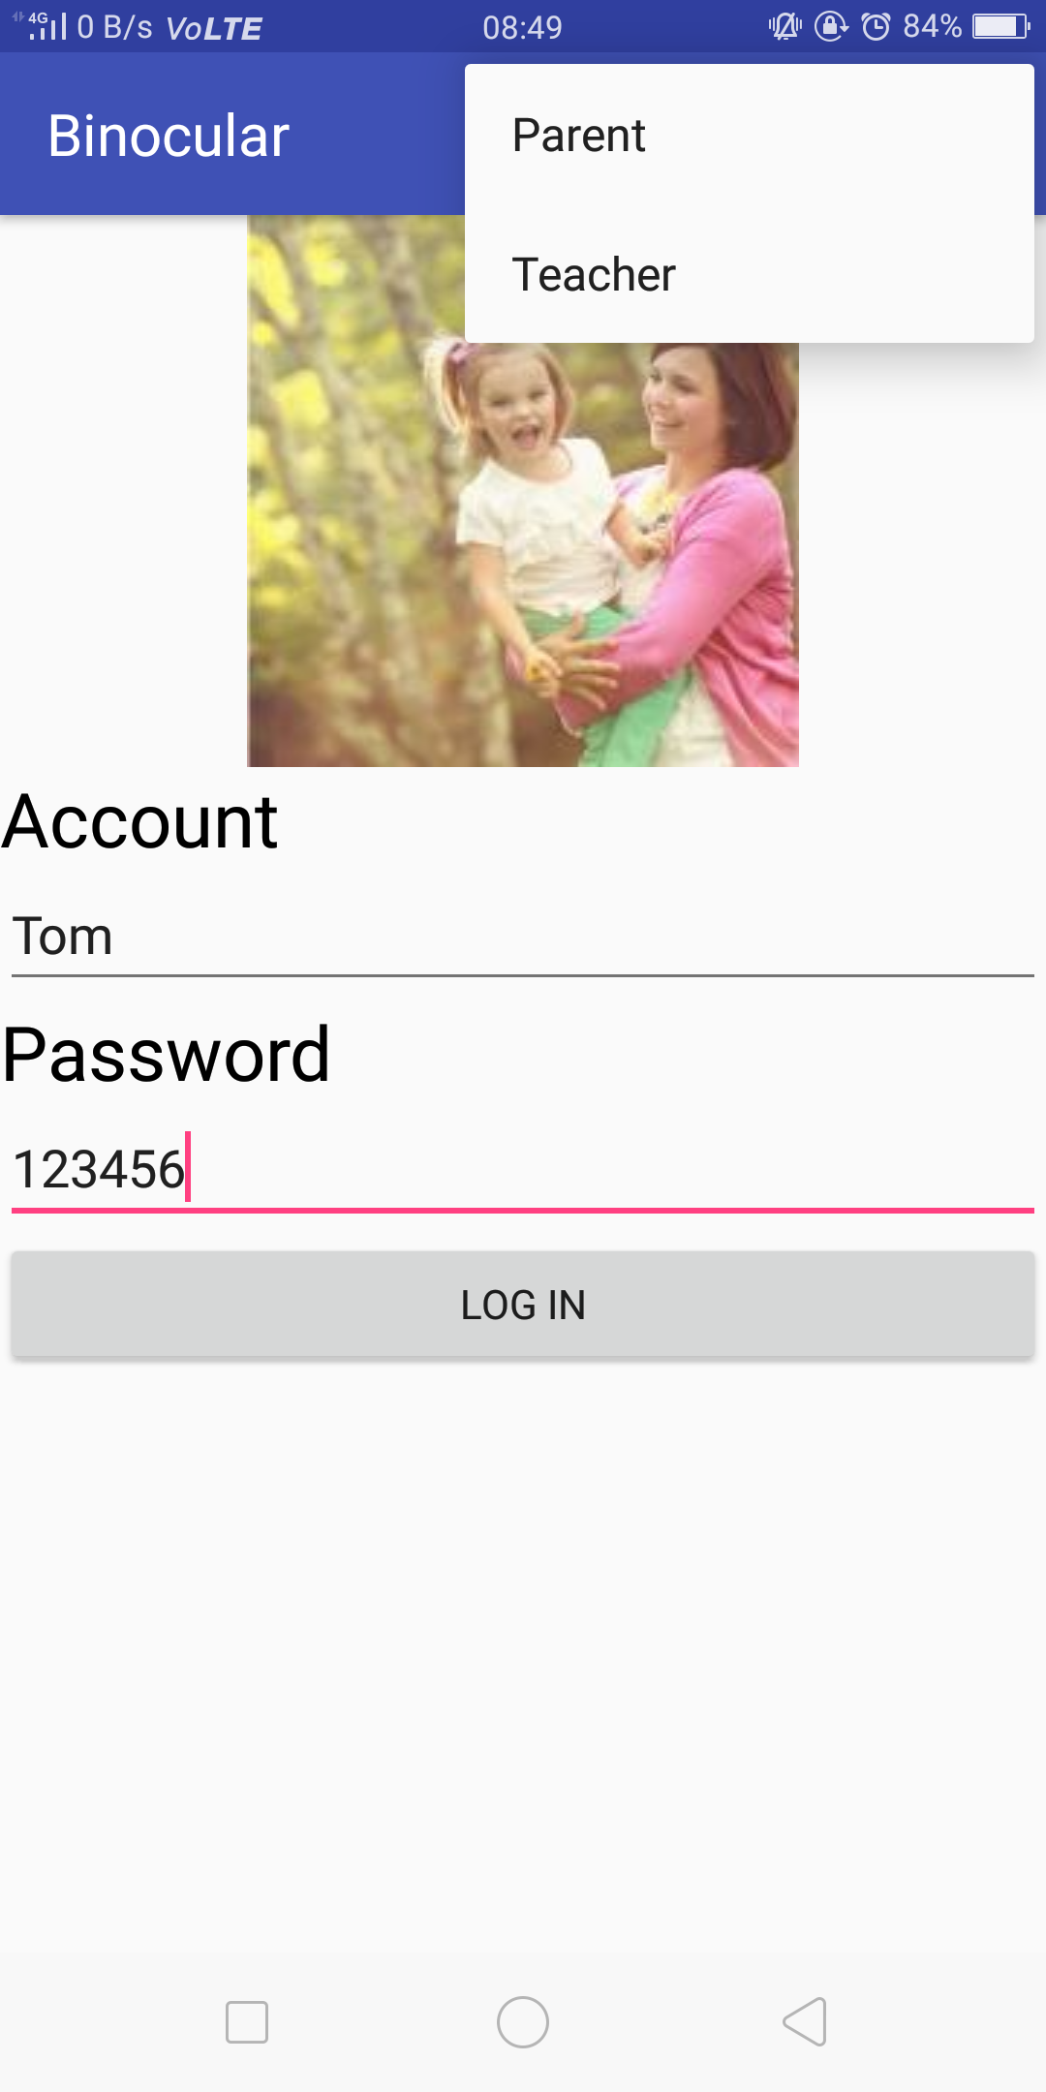 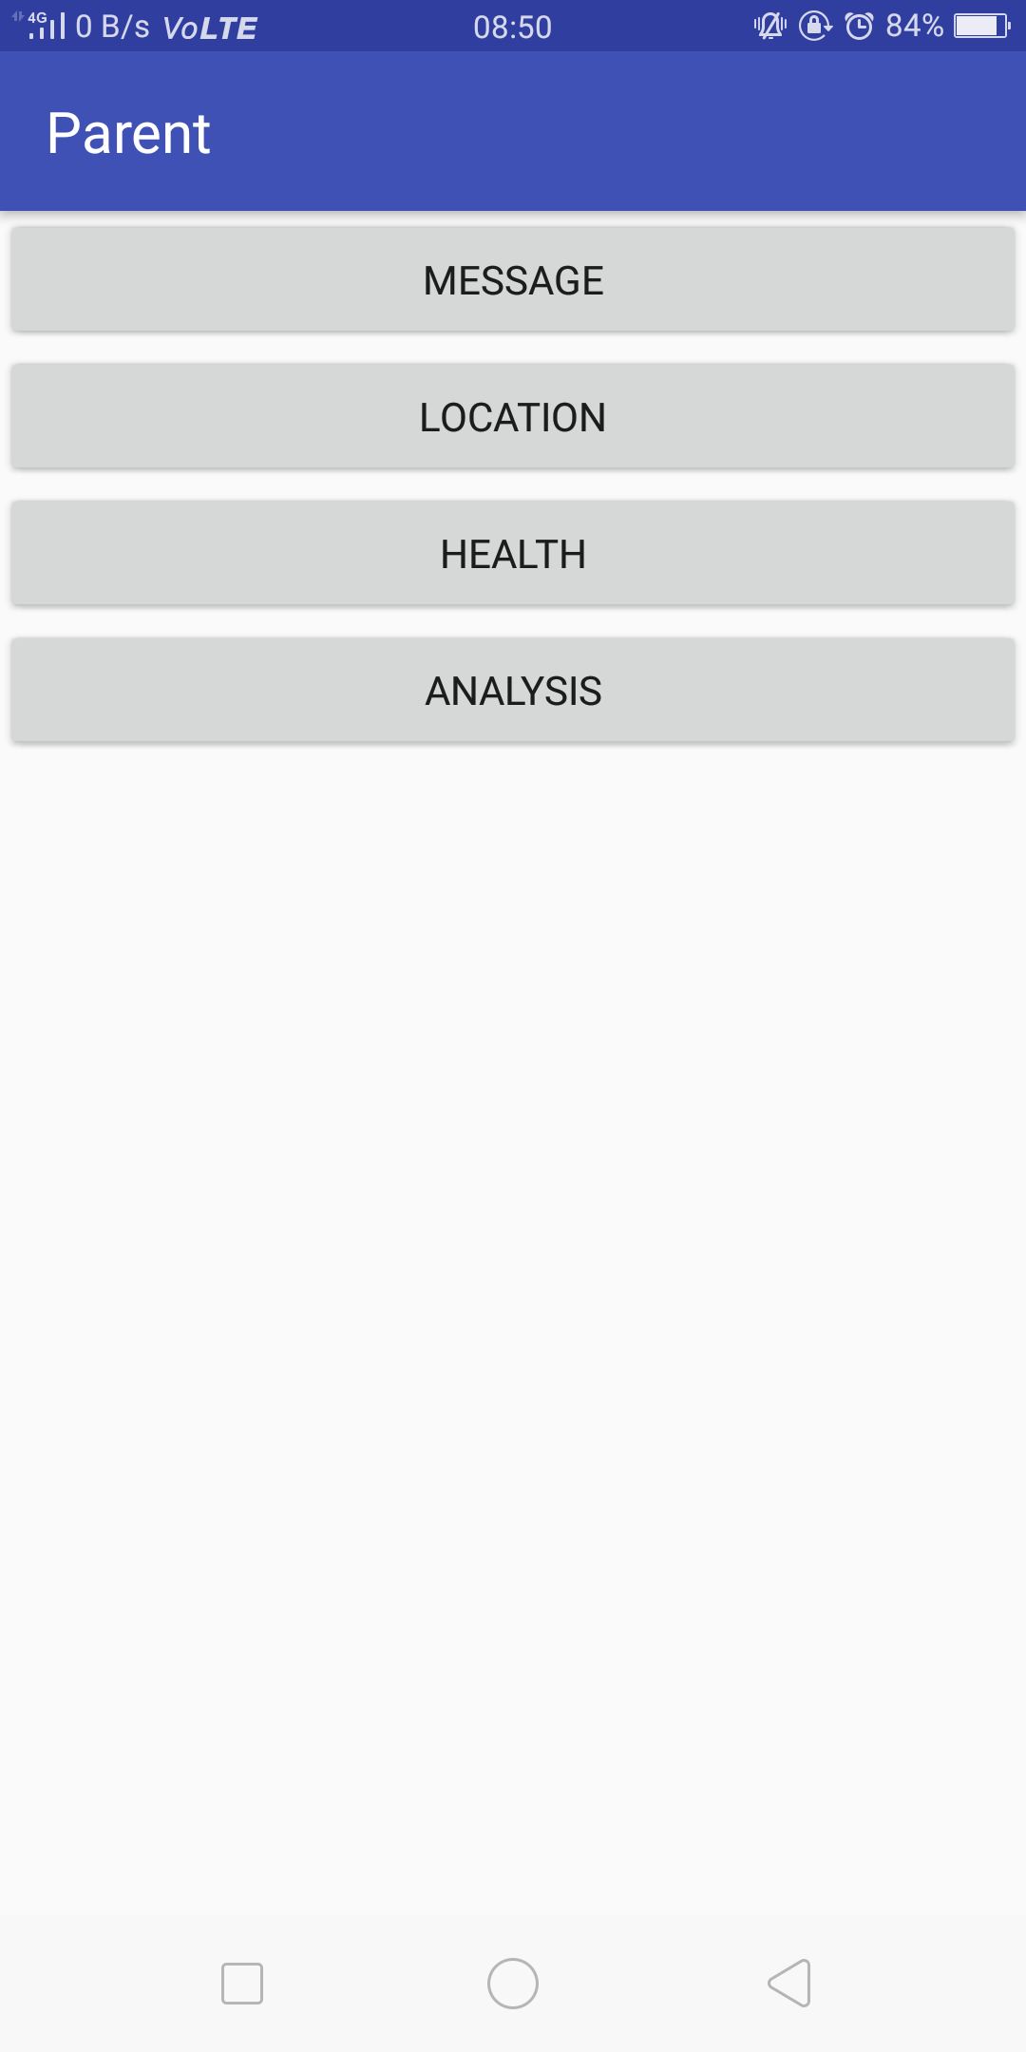 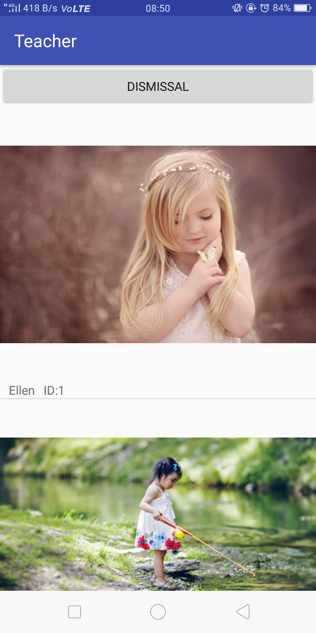

The functions in the parent end

 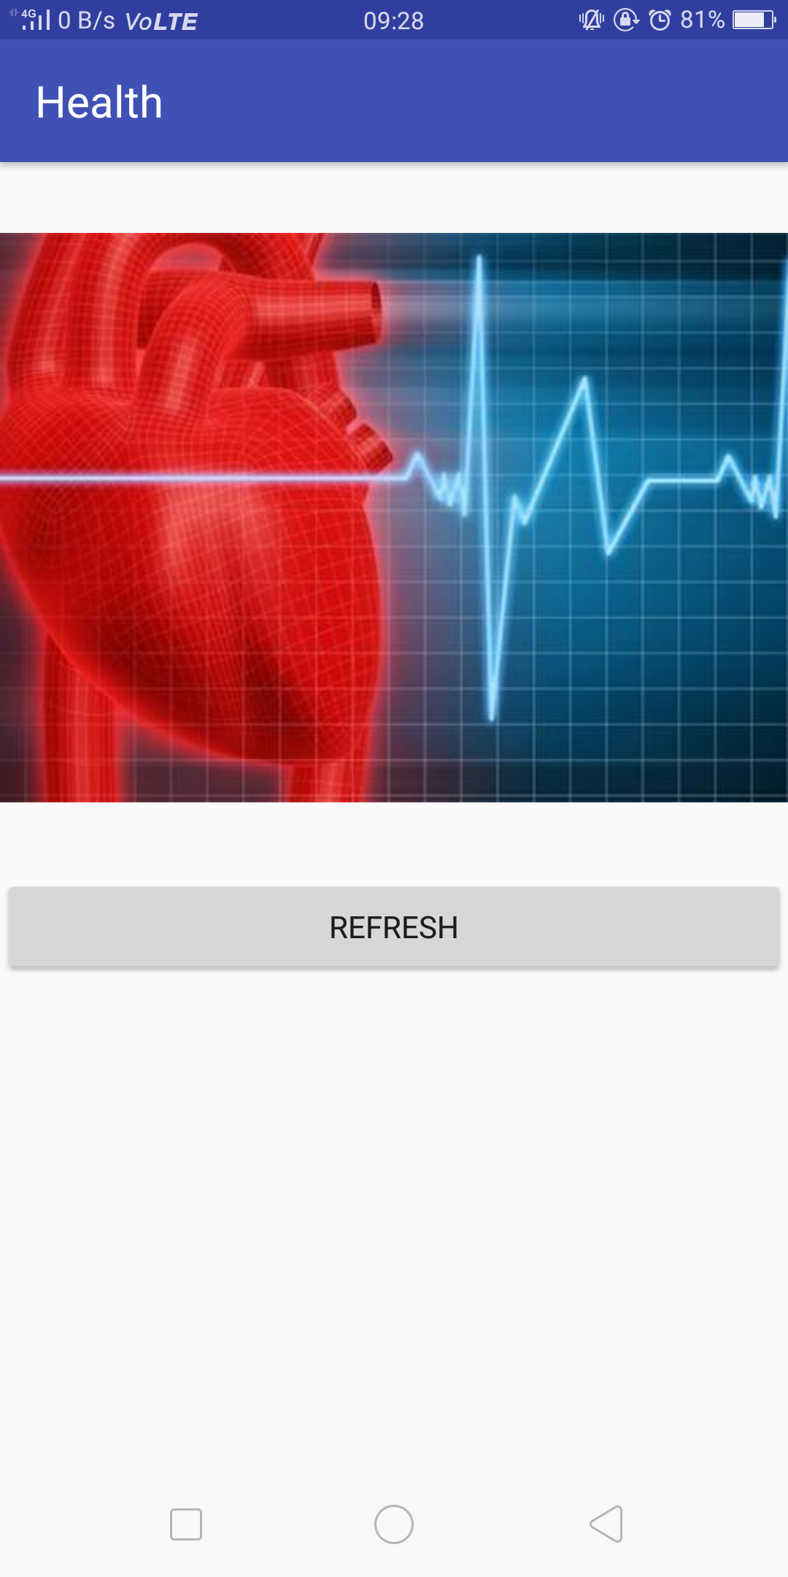 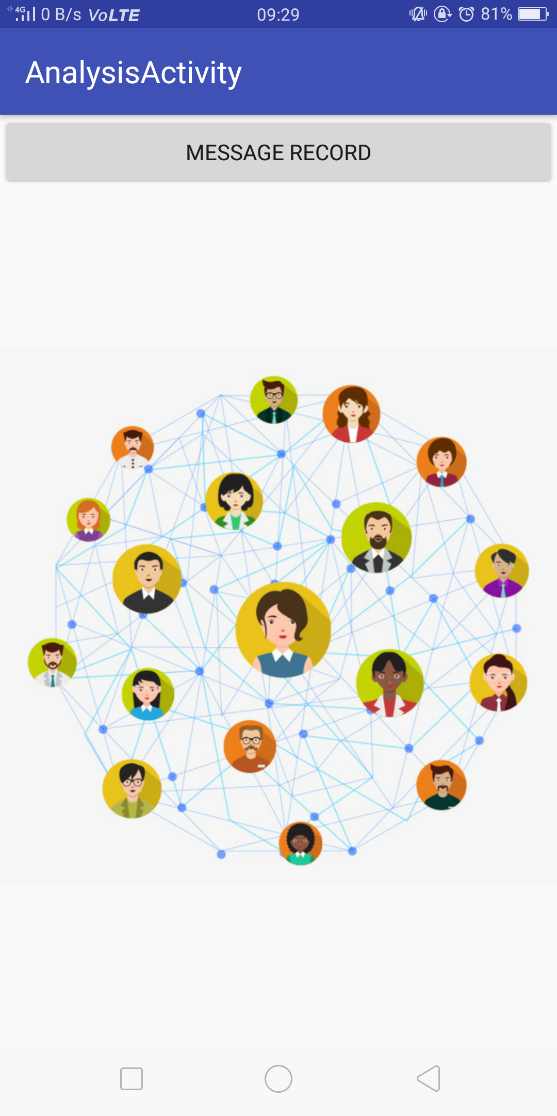 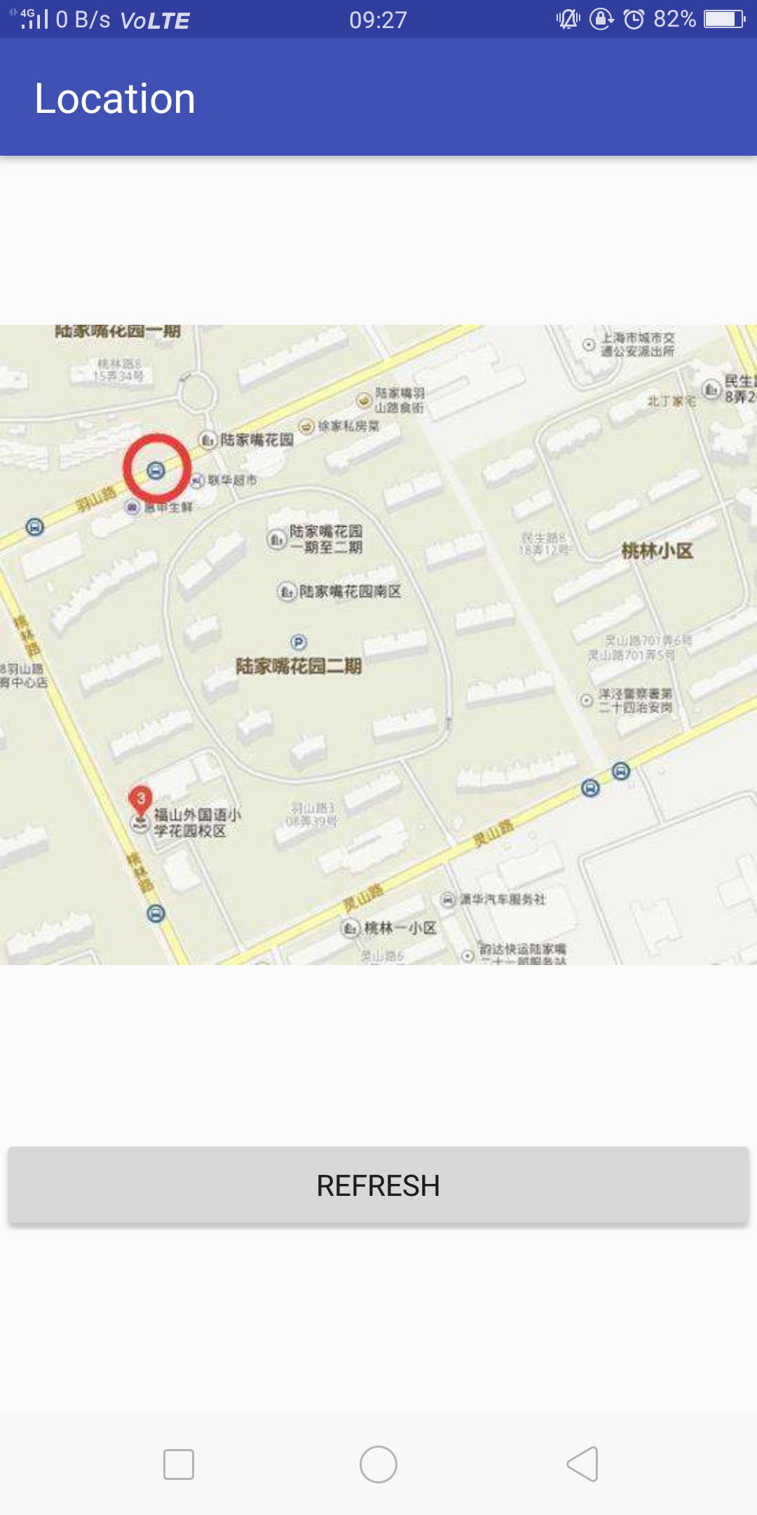

The functions in the teacher end

 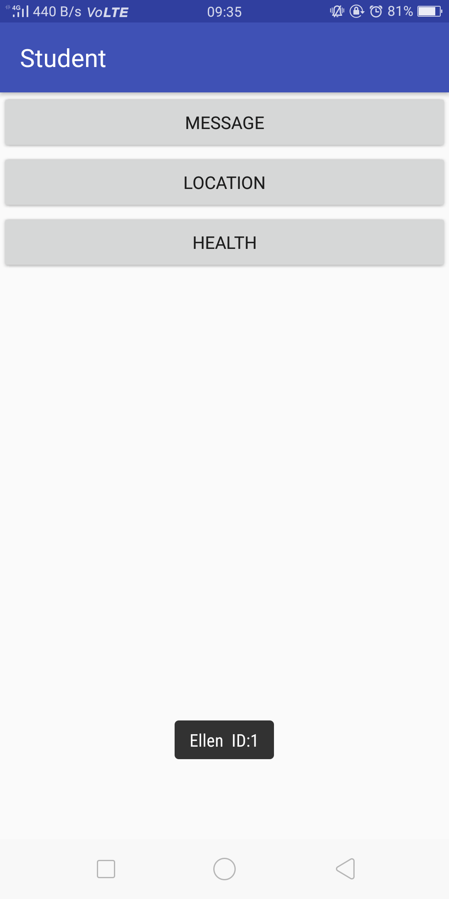 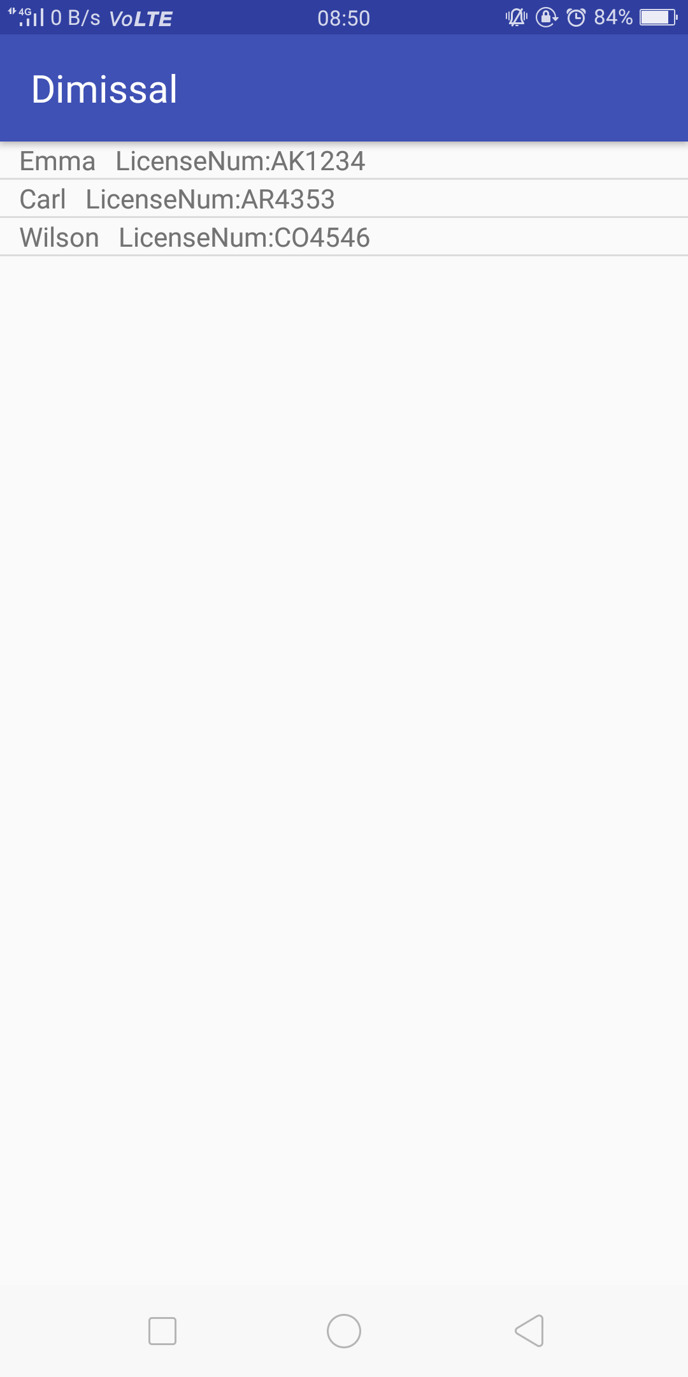

3.2 PC (Made by me)

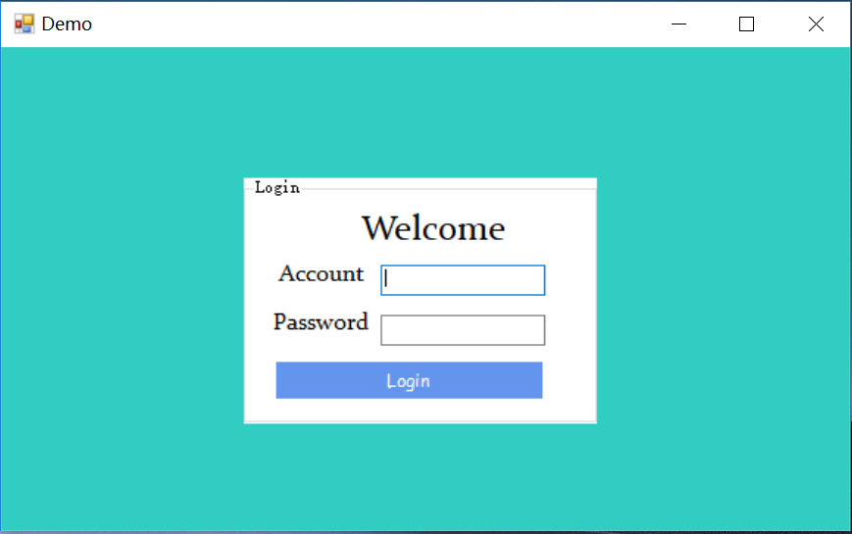 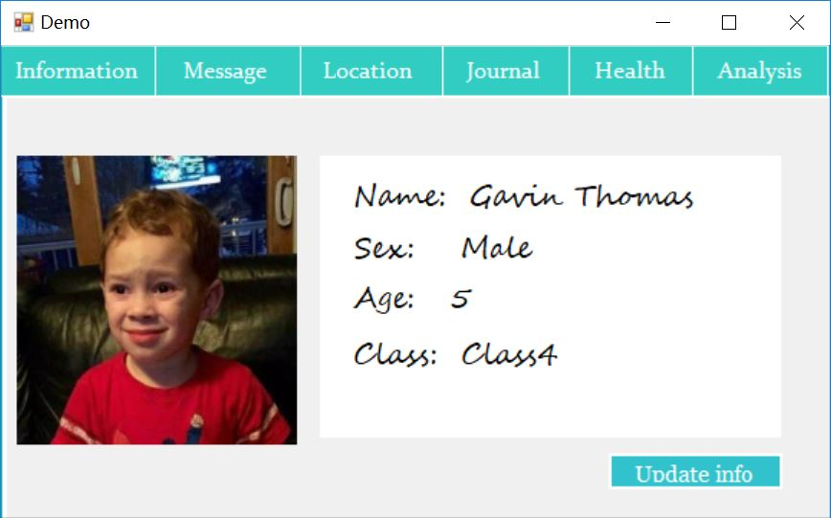

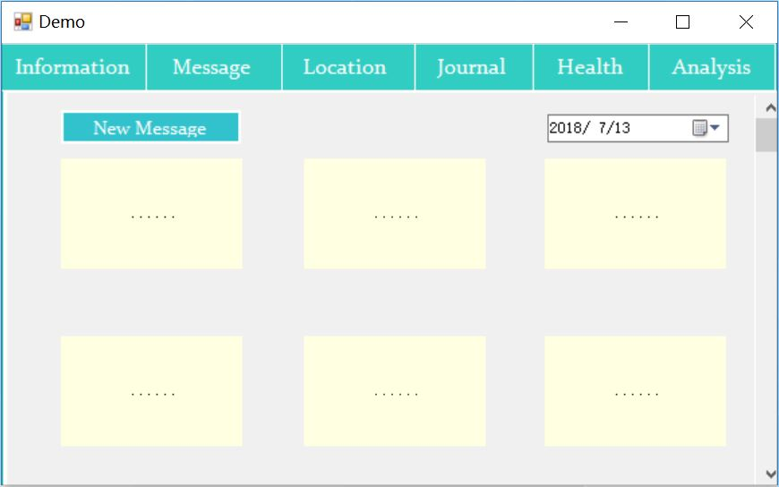 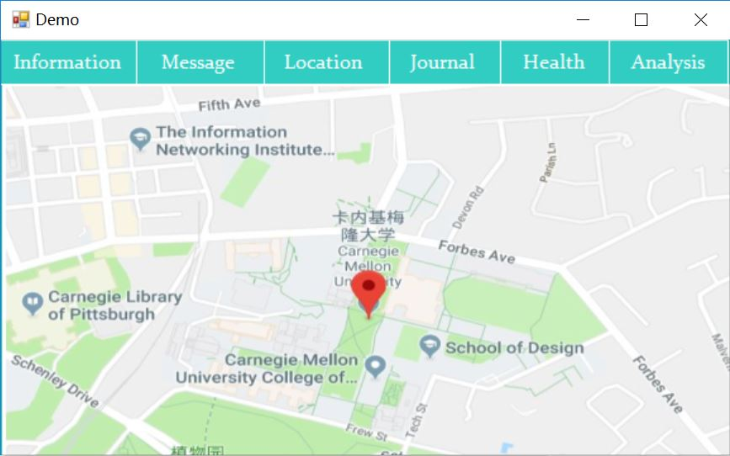 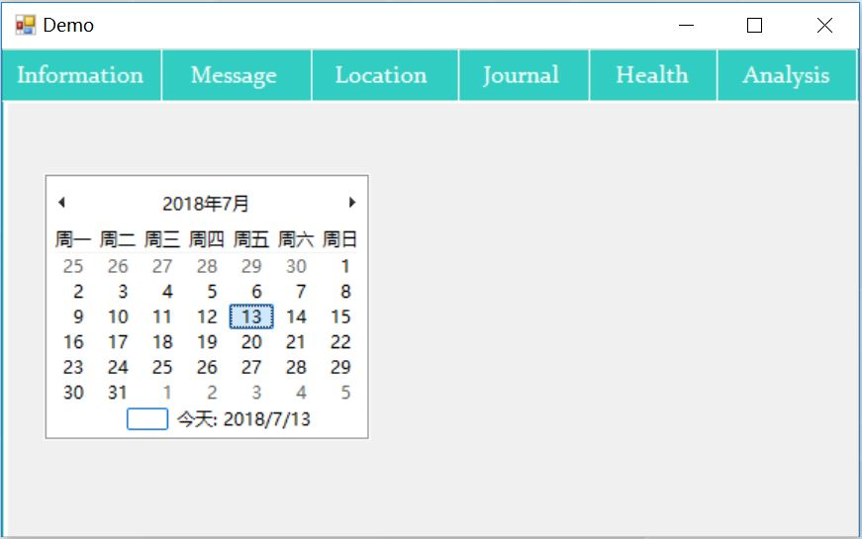

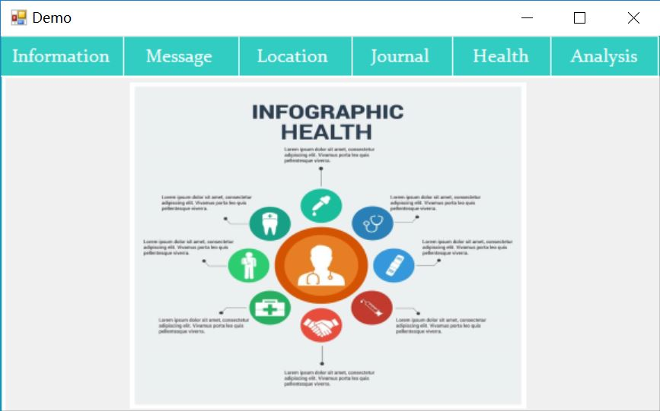

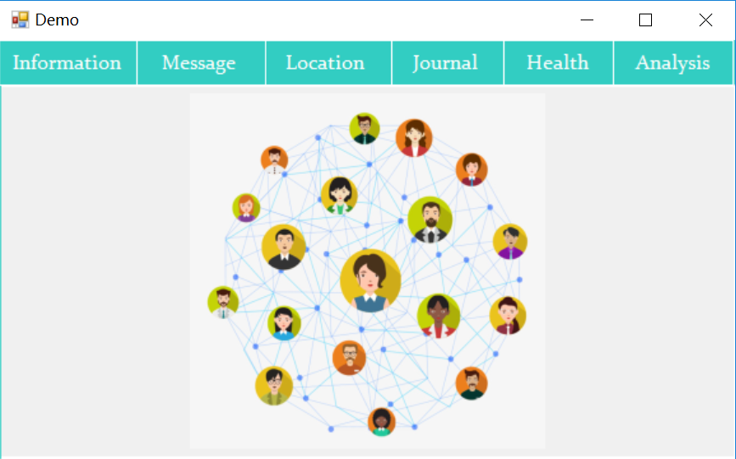

3.3 Website

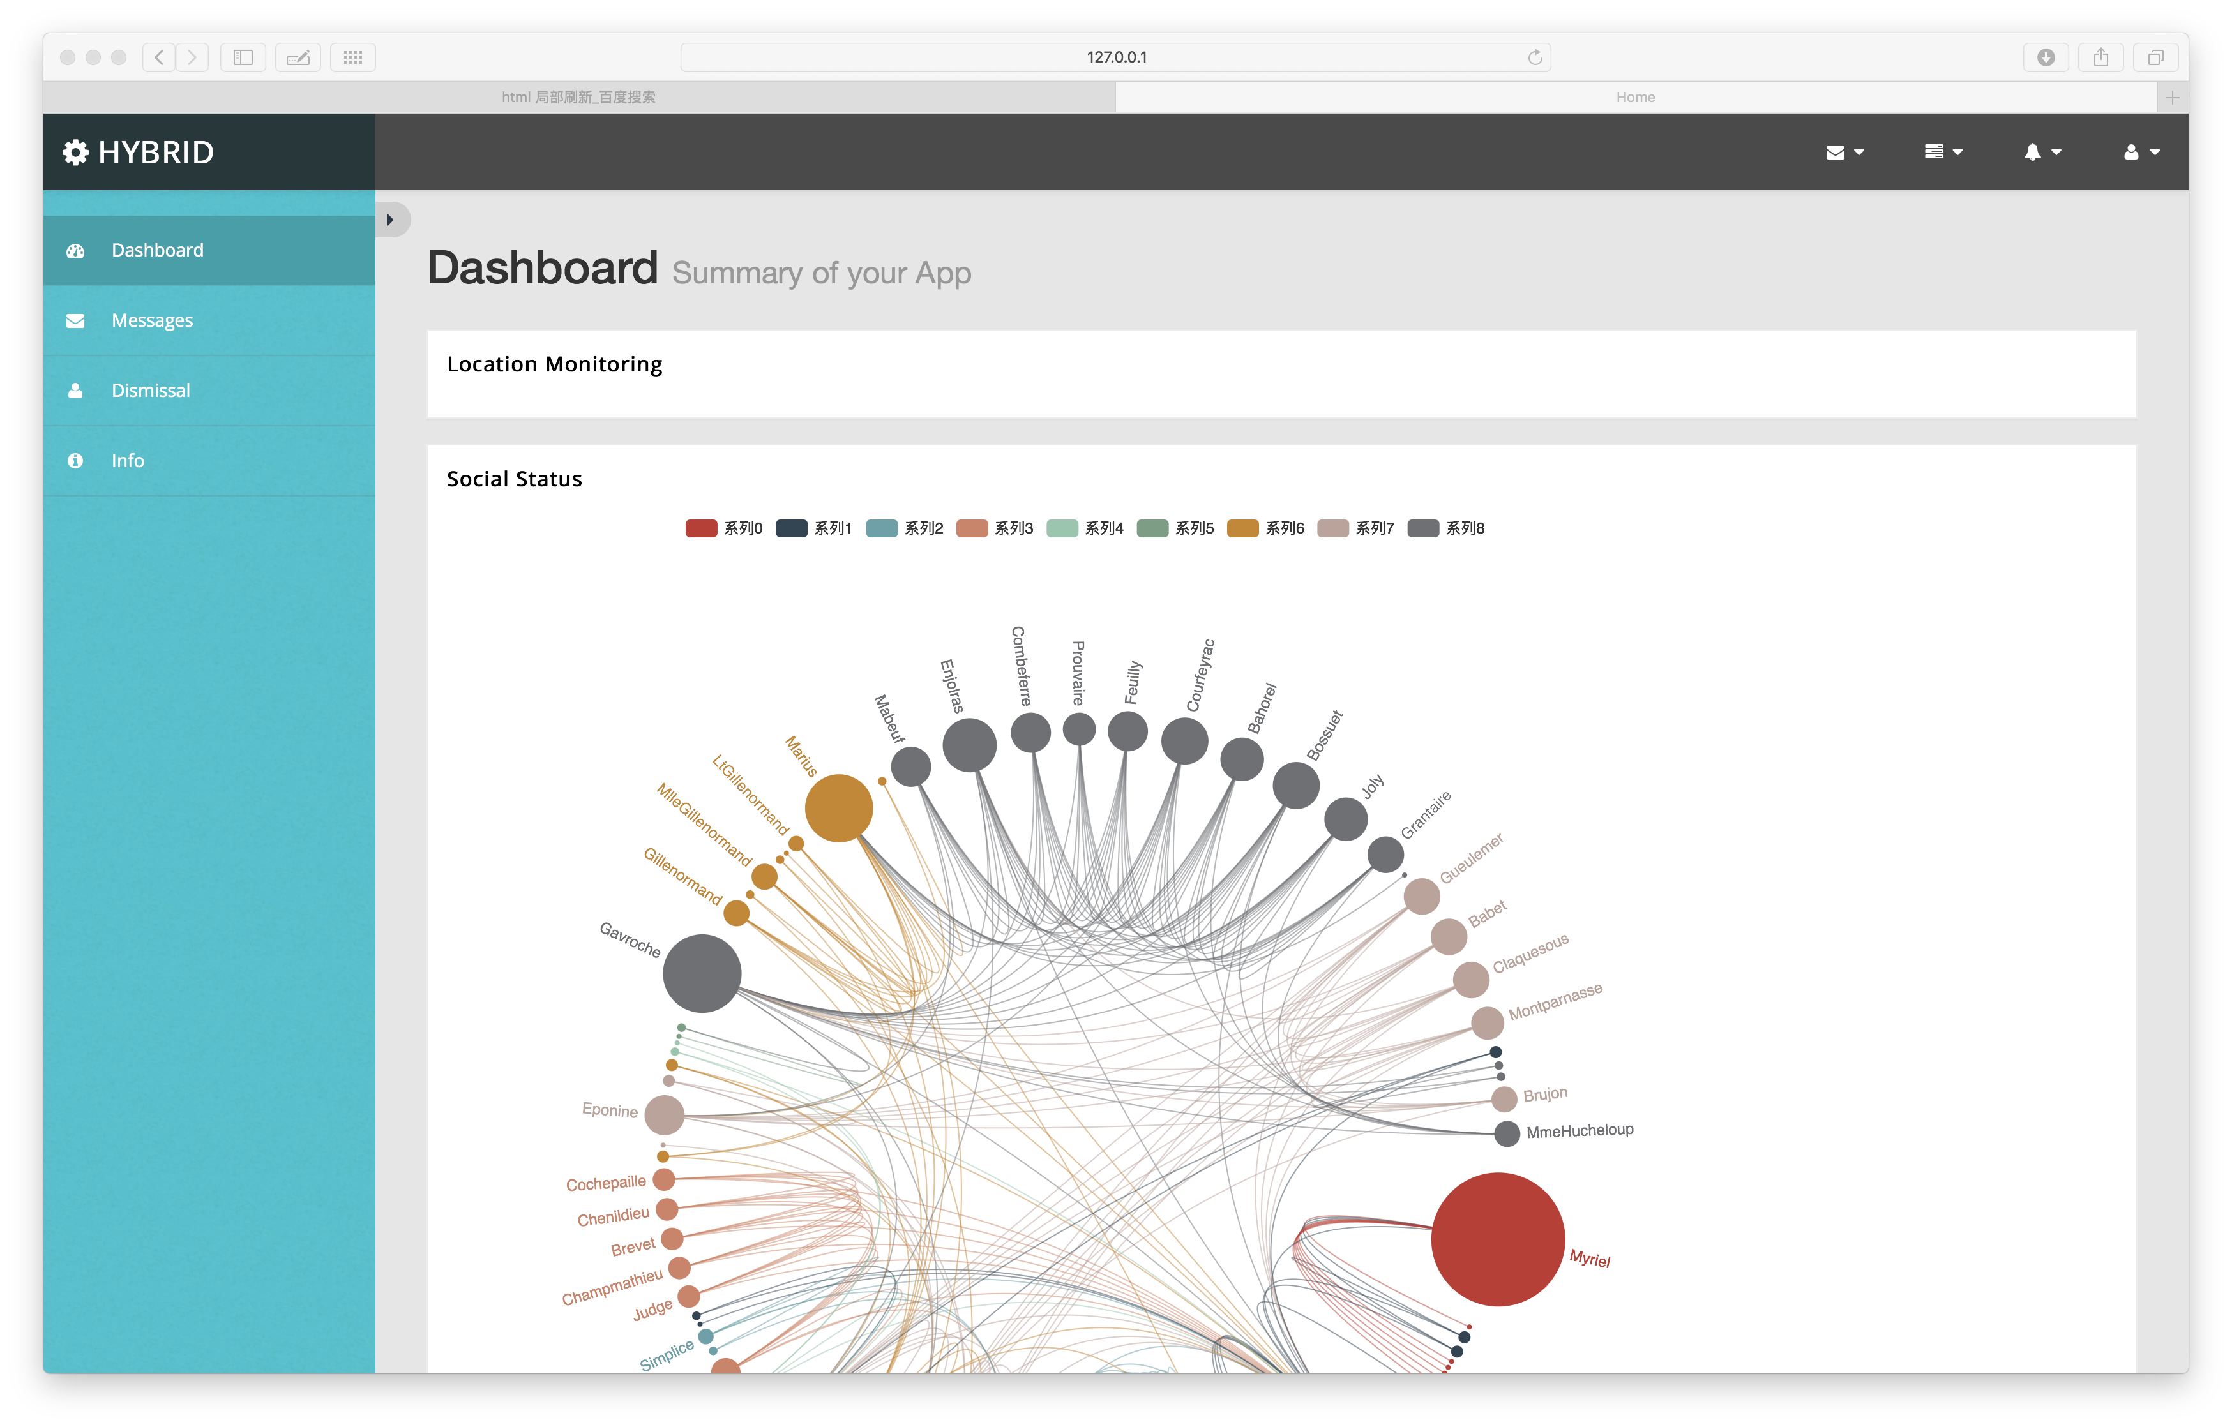

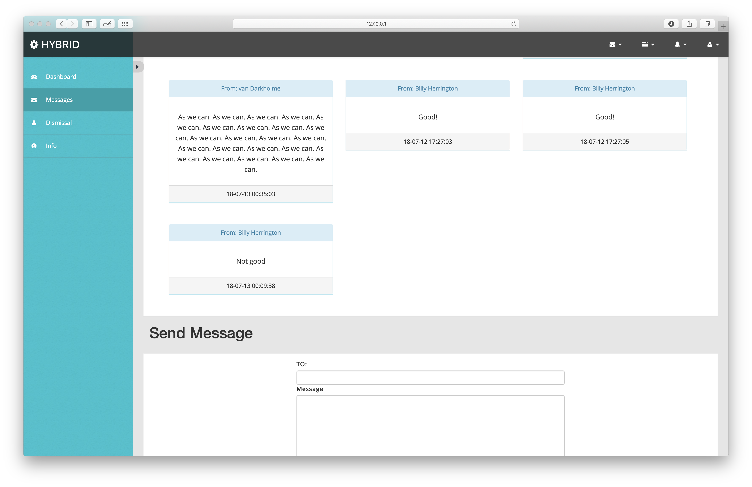

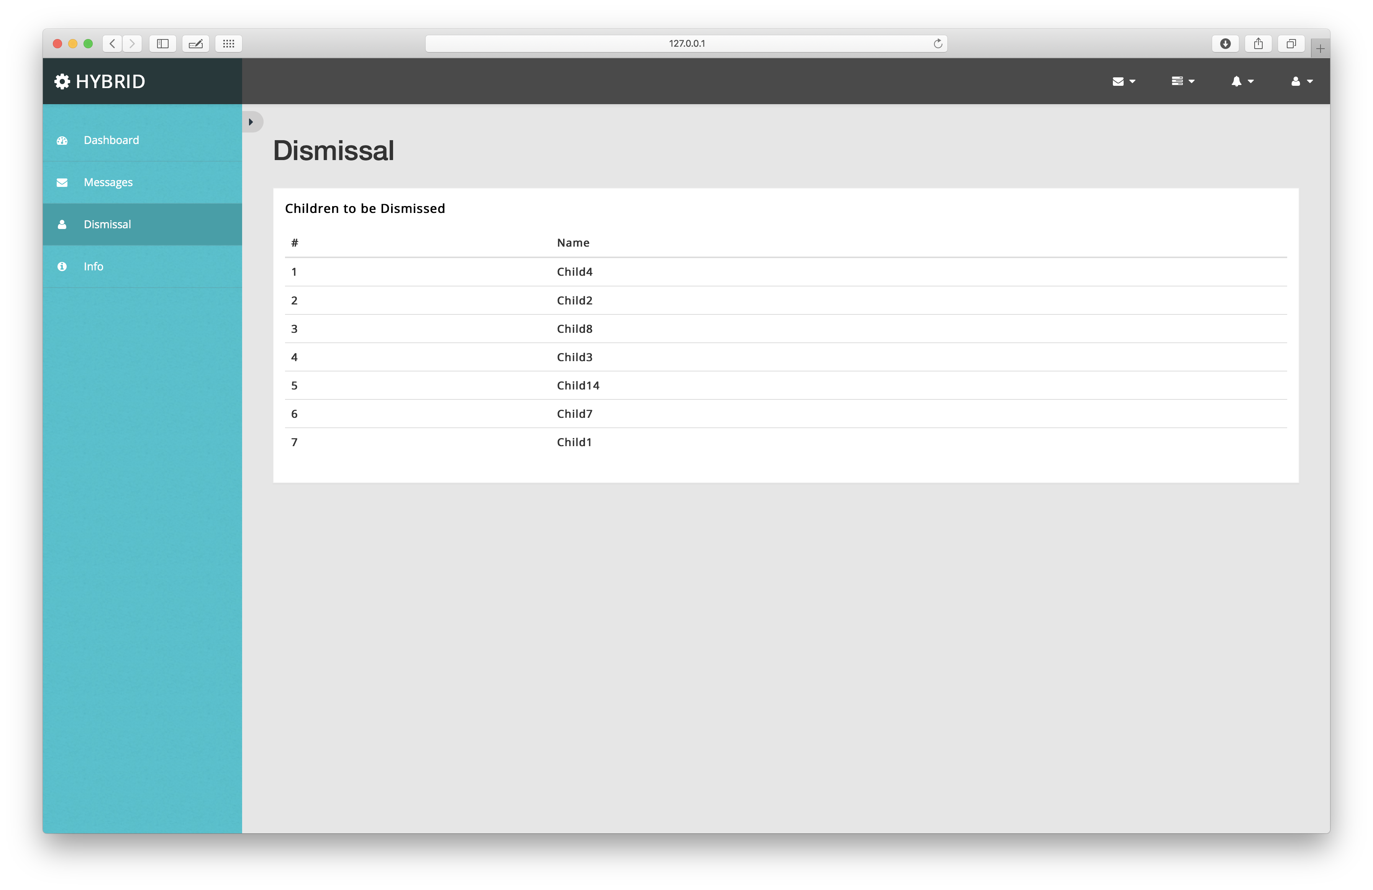

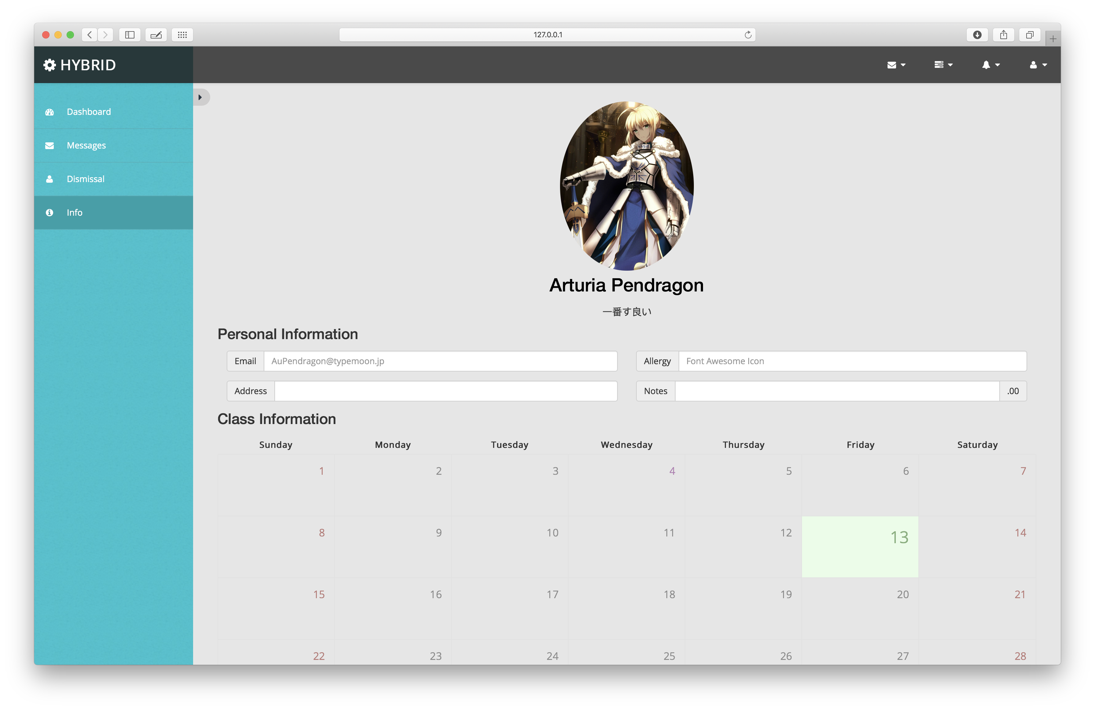

**4 Lesson Learned**

This is the first time for me participating in this kind of class. Be aimed at solving a specific problem in real life, we are required to design a prototype and implement it by different groups’ cooperation. It’s a really fresh experience to me. We discussed about the problem and give a visionary scenario at first. Then the groups go work on the missions. We experience a whole progress of a project development, met some difficulties and figure out how to solve them. We had gone through a really hard-working week, but also gained a lot. It’s really a special experience.